Identification of Unknown B
Sophia Karolewics
Partner(s): None
11/28/23
Chem 2081 Section 004

Introduction
The goal of this lab report is to identify Unknown B. To identify this unknown multiple things will need to be interpreted like Nuclear Magnetic Resonance (NMR), Gas Chromatography/Mass Spectroscopy (GC/MS), and Infrared Spectroscopy (FTIR). It is important for an organic chemist to have the skills to identify an unknown compound using the data types above for a multitude of reasons. A scientist can ensure that an unknown compound is identical to another known compound that was previously reported. The structure of molecules can be determined, concentration measurements can be done, and interactions can be observed. Also, these types of analyses can help chemists further understand chemical structures, purity, function, and potential application. Therefore, there is plenty of motivation for chemists to understand these data types.
Discussion
NMR stands for nuclear magnetic resonance; it works by sending a broad pulse of electromagnetic radiation that will excite all of the H or C nuclei, this will result in oscillations that will continually decrease which is caused by the excited nuclei decaying back to their previous distribution. Scientists have labeled the oscillating as a free-induction decay. This is then converted to a set of frequencies. Therefore, there are three main steps when considering the principle of NMR which are: magnetic nuclear spins being polarized in an applied constant magnetic field B0, a weak oscillating magnetic field disturbing the alignment of the nuclear spins, the electromagnetic waves that come from the nuclei after the disturbance are detected and analyzed. To read an NMR spectrum many things need to be considered like chemical shift, spin multiplicity, coupling constants, and integration. The first thing that should be examined is the number of signals in a spectrum, which will indicate the types of protons in a compound. The chemical shift value should be determined next, and this will show the magnetic environment of protons. Then when looking at the multiplicity of every signal this shows how many neighboring protons are coupled to the signal. The integration value can be considered next, and it will indicate the number of protons in every signal. The correct fragments of every signal can then be drawn and assembled.
FTIR is important for finding which functional groups are in a molecule; it measures energy as a frequency or wavelength and it is plotted through a horizontal axis, how intense the absorption is will be plotted along the vertical axis. Furthermore, there are multiple different ways to plot the data, but it mainly depends on the scales used for the axis. IR has commonly been called vibrational spectroscopy to describe the movements of atoms relative to each other. Four main factors that commonly affect the intensity and frequency of IR peaks are the type of vibration, masses of atoms attached by covalent bonds, electronegativity difference between atoms or groups of atoms in a bond, and strength of the bond connecting the atoms. The first thing to look at when trying to analyze an IR spectrum is to look at the 1850-1630 cm^-1 region of the spectrum. A strong peak in this region indicates a carbonyl group; if a carbonyl group is indicated peaks in other parts of the spectrum. The next step would be to check the 3550-3200 cm^-1 region; if there is a strong, broad signal then that is an indication of a hydroxyl group of an alcohol. The stretching region at 3310-2850 cm^-1 should be looked at next, if there is a strong, sharp peak then that is an indication of a terminal alkyne group. The 2280-2100 cm^-1 region needs to be checked for a possible tripled bond CN group, a strong peak near 2250 cm^-1 is an indication of this. However, a medium to weak intensity peak close to 2170 cm^-1 will be an indication of a triple-bonded CC group. The 1300-1000 cm^-1 region will need to be checked next to determine whether or not an ether group is present if there are one or two strong absorptions in the region. The next step would then be to list out all functional groups recognized and then piece it together into a chemical structure.
Mass spectrometry works by ionizing a sample by its electron impact and uses a magnetic sector mass analyzer to sort its ions. GCMS is a hybrid which combines a gas chromatograph and a mass spectrometer. This is done by taking effluent steam from a gas chromatograph and leading it into a mass spectrometer. The molecules will then be ionized by electron impact, and the ions that are left are accelerated and then put into a mass analyzer. The end product is a mass spectrum for every compound that came from the gas chromatograph. This data is presented using a graphical form as a histogram which puts ion intensity in the y-axis and retention time on the x-axis. How intense it is is represented in the form of a percentage at the most intense peak of the spectrum, this is called the base peak. A successful interpretation leads to structural information based on the structure’s mass. To do this the relative abundance of the (M+1) peak needs to be divided by the molecular ion’s relative abundance. Doing this will determine the number of carbons present in a molecule and masses already listed in a periodic table can be used to show what other molecules will be found in the structure.

Data
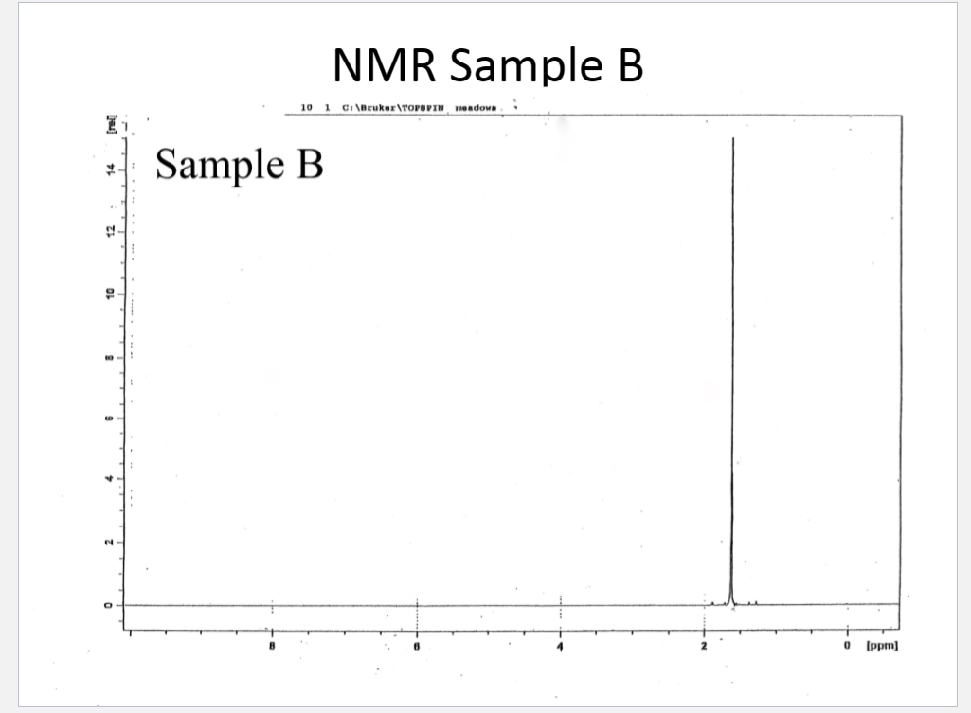
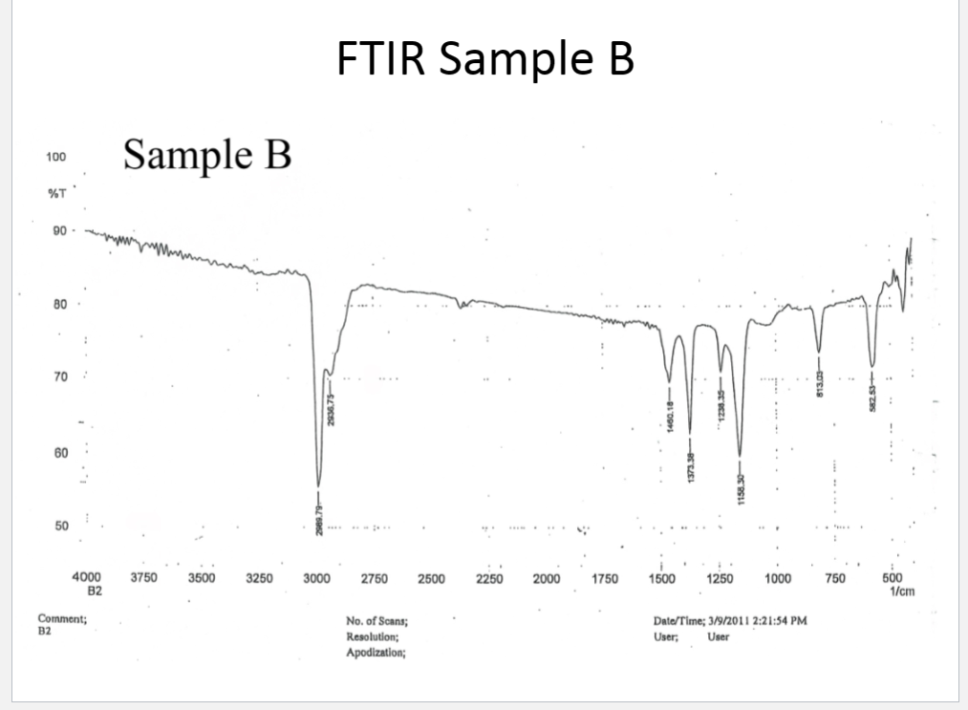

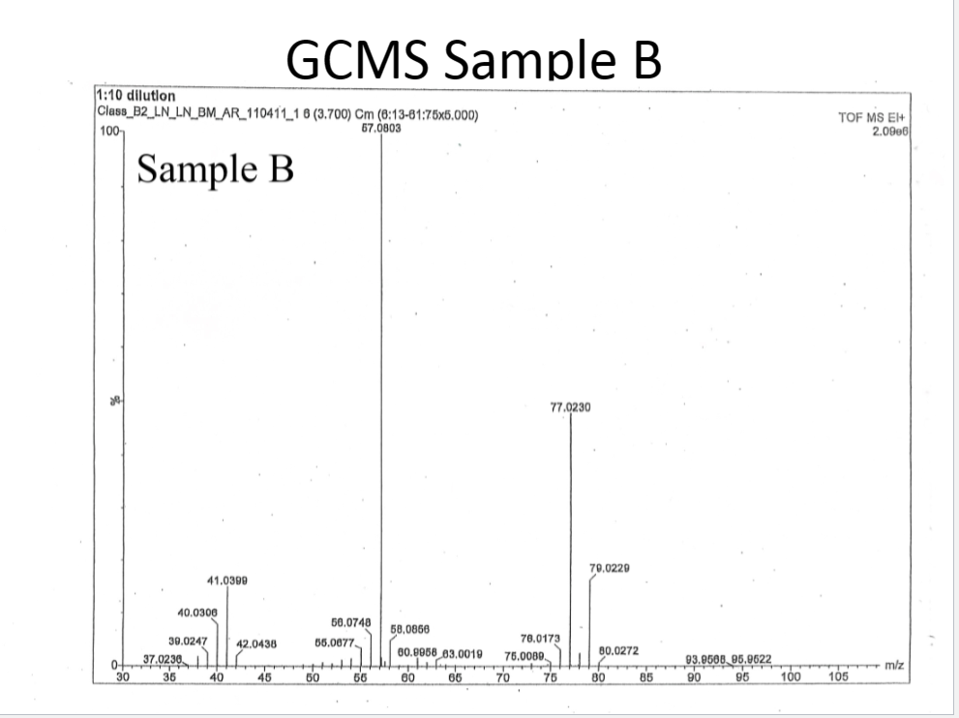
Analysis
The first observation of the NMR spectrum is that there is a singlet signal at 1.6 ppm. It can be assumed there is a halogen in the unknown structure instead of an alkane because alkanes do not usually display signals further downfield than 1.2 ppm; since the singlet signal is at 1.6 ppm alkanes can be ruled out. Furthermore, only one split can be seen in the NMR, which indicates that there will only be one proton type in this Unknown B. This also can be an indicator of the protons in the compound being equivalent and the compound being symmetric. The signal integration can be derived from the height which indicates ten protons being in the compound. The existence of carbon-hydrogen bonds in the structure can be determined by looking at peaks 2989 cm^-1 and 2937 cm^-1. In addition, there are many peaks that can be observed from 1,000 to 1,500 cm^-1 this is an indication of multiple methyl groups. The halogen chlorine is identified by looking at peaks 582 cm^-1 and 813 cm^-1. Although, the 813 cm^-1 is outside of the normal range of a carbon-chlorine bond; this could mean there are other groups around the carbon that the halogen is attached to. When looking at the GCMS spectra a base peak at 57 m/z can be observed, the molecular ion is found at 93.95685 m/z. Also, the (M+1) peak is seen at 80.0272 m/z. When referencing the periodic table chlorine’s atomic mass is (35.45 amu) which is an indication of four carbons being in the compound. The information from these spectra can be used to identify the unknown compound.
Conclusion
To summarize, the main things determined when looking at the three data types are: Unknown B has chlorine, is symmetric, there are ten protons, one proton type, carbon to hydrogen bonding, multiple methyl groups, and four carbons. Furthermore, there is a small increase around 800cm^-1 in the FTIR which is an indication that chlorine is attached to the central carbon. Also, it was already assumed there was symmetry in the compound, so the other alkanes would need to be attached to the central carbon. The NMR also indicates that there is no hydrogen bonding at the central carbon. When considering all of the information listed above, it can be assumed that Uknown B is tert-butyl chloride.
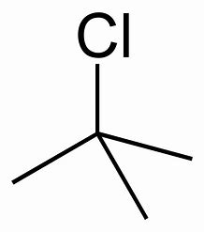Image 1. A visual picture of Unknown B.
References
Keller L, Joseph K, and Miguel S. 2023 Fall. CHEM 2081 Organic Chemistry II Lab Manual [lab manual]. Auburn (Al): Auburn University.

